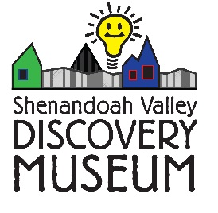
Planned Giving
Shenandoah Valley Discovery Museum Legacy Leaders
We invite you to join the Shenandoah Valley Discovery Museum’s Legacy Leaders. Making a planned gift to the Museum’s endowment is a flexible and creative way to have an impact by giving charitably while meeting your personal, family or financial goals. Creating a legacy gift can be an especially meaningful way to ensure the vibrancy, stability and sustainability of the Museum. No matter your financial circumstances and charitable goals, there are planned giving options available to meet your needs.

Making a planned gift to the Shenandoah Valley Discovery Museum offers you a flexible and simple way to combine philanthropy with long-term financial planning. In fact, a planned gift may help you give more to the Museum than you thought possible, while still providing you or someone you designate, with favorable financial and/or tax benefits. Below are just some of the options!

Appreciated Assets

Donating appreciated assets is one of the most tax-efficient ways to give. You can simultaneously reduce your capital gains tax and potentially your ordinary tax by transferring appreciated assets to the Museum. Appreciated assets take many forms, including stocks, bonds, real estate and other tangible property.

Bequests
The most popular and easiest method of leaving a legacy gift is to include the Discovery Museum in your will, estate plan or living trust. Your assets remain in your control during your lifetime and you can modify your bequest at any time. This offers you great flexibility as you plan for the legacy you want to leave behind.
Sample bequest language*: “I give the Shenandoah Valley Discovery Museum, a Nonprofit Corporation (Tax ID #54-1692942) incorporated in Virginia, and having its principal offices at 19 W. Cork St., Winchester, VA 22601, the sum of $______ (or alternately, ____% of the residuary of my estate, or gifts of appreciated assets, IRAs, real estate,…) for its general purposes.”

Retirement Plan Gifts
Naming the Discovery Museum as the beneficiary of your IRA, 401K, or other qualified retirement plan is a simple and tax-efficient way to benefit future generations. This lets you remain in control of the process: you can continue to take withdrawals during your lifetime while making the Discovery Museum a full or partial beneficiary. After your lifetime, the residue of your plan passes to the Discovery Museum tax-free and your estate may generally receive a charitable estate tax deduction as well. Or you can designate the Museum as a potentially tax-deductible recipient of your regular withdrawals.
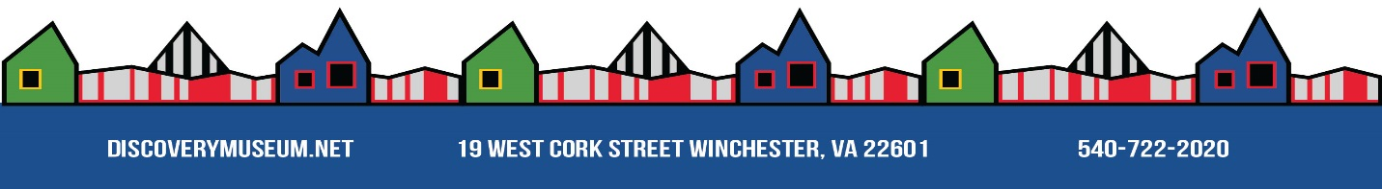
Life Insurance Designations
Making a beneficiary designation through your life insurance plan is an easy and affordable way to support the work of the Discovery Museum. By naming the Museum as the beneficiary of an individual or group life insurance policy, the benefits from your policy will pass to the Museum.
Or, you can enroll in a new life insurance policy making the Discovery Museum a beneficiary. Through quarterly donations to the Museum, your premium payments can be tax-exempt to you while paid to the insurance company by the Museum.

Charitable Gift Annuities
With a Charitable Gift Annuity (CGA), you can support the work of the Discovery Museum now while retaining secure, fixed payments for life. A CGA accomplishes two goals – preserving income through fixed payments to you and/or your loved ones, and providing valuable support to the Museum. You may also receive an immediate income tax deduction, AND waived tax on capital gains by virtue of your annuity gift.

CGAs to the Museum can be funded with cash or appreciated assets valued at $10,000 or more by persons age 65 or older. Charitable Gift Annuity rates depend on your age when you make the gift. Contact us for current rates and deductions, and know that interest rates are favorably increasing effective July 1, 2018.

Charitable Remainder Trusts
You can transfer cash, securities or other appreciated property into a trust. CRTs are designed to reduce the taxable income of individuals by first dispersing income to the beneficiaries of the trust for a specified period of time and then by donating the remainder of the trust to the designated charity.
Each year the trust pays a percentage of its value to you or to the beneficiaries you name. After the death of the last beneficiary, the remainder of the trust will pass to the Discovery Museum to support our programs for future generations. You typically will receive an immediate income tax deduction for a portion of your contribution to the trust; the trust pays no capital gains tax when it sells the assets you have contributed; and you or your designated beneficiaries receive income for life or for a term of years.

*Please Note: each state has its own particular rules that apply to planned giving options, and because the requirements for the gift vary depending on where you reside now or in the future, we strongly recommend that you consult your tax advisor and/or an estate planning professional. If you are seeking a knowledgeable lawyer or CPA to ensure your intentions are met, the Museum will be happy to furnish you with a list of accredited professionals.
Thank you for you for contemplating the difference that your legacy can make!
